Paper Title
John Doe, Random University
Jeanne Doe, Highest-Ranked University
2023-10-25
Abstract
Abstract: this research is so awesome that you cannot reject this paper.

Introduction 2
Materials and Methods 3
Data 3
Statistical Model 3
Lalala 3
Results and Discussions 3
Conclusions 3
Figures 4
Tables 5
Use the modelsummary package to create regression results tables 5
The gt package does not work well 6
References 6
Appendix 6

Introduction
The issue this article addresses is super important!
- author names and year: Schlenker and Roberts (2009) examined ….
- author names and year in parentheses: (Schlenker and Roberts 2009)
- multiple citations in parentheses: (Mas-Colell et al. 1995; Schlenker and Roberts 2009)
- only year in parentheses: (2009)

Materials and Methods
This line break does not work: See?
This line break does work:
See?

Data
The number of observations are 598 and 1376 for Zones 2 and 3, respectively.
Table 1 presents summary statistics by zone.

Statistical Model
See equation (1) and (2) for the statistical models we use.
$$y=β_{0}+β_{1}x+ε \left(1\right)$$
$$\begin{matrix}Y_{z} & =f_{z}\left(S\right)+g_{z}\left(N\right)+h_{z}\left(X,Y\right)+ε_{z} \\ & =\sum_{i=1}^{k}{ϕ_{k}}\left(S\right)+g_{z}\left(N\right)+h_{z}\left(X,Y\right)+ε_{z} \left(2\right)\end{matrix}$$
Our target coefficient is $β_{1}$ (in-line math).

Lalala

Another heading

Results and Discussions
Table 2 presents the regression results.
Figure 1 presents the distribution of yields by zone.

Conclusions
bluh bluh, another bluh bluh

Figures
I like Figure 1 a lot.
Figure 1: The Distribution of Yield by Zone

Figure 2 was imported.
Figure 2: Imported Plot
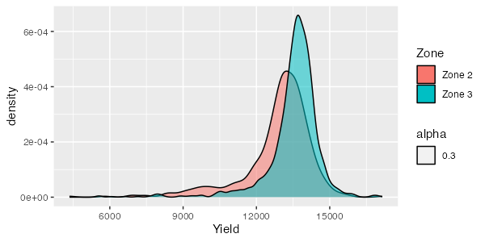

Tables
Zone |  | get_N | Mean | SD | Min | Max
Zone 2 | Yield (kg/ha) | 598 | 12876.63 | 1445.67 | 4349.84 | 17150.77
 | Nitrogen Rate (kg/ha) | 598 | 117.82 | 14.73 | 88.94 | 145.57
 | Seed Rate (1000/ha) | 598 | 84.01 | 6.86 | 69.17 | 98.61
Zone 3 | Yield (kg/ha) | 1376 | 13530.20 | 1093.98 | 5539.50 | 16966.78
 | Nitrogen Rate (kg/ha) | 1376 | 118.20 | 14.61 | 88.84 | 143.75
 | Seed Rate (1000/ha) | 1376 | 87.20 | 7.03 | 69.58 | 98.82
Table 1: Summary Statistics by Zone

Use the modelsummary package to create regression results tables
 | (1) | (2) | (3)
(Intercept) | 36.908 | 38.752 | 38.752
 | (2.191) | (1.787) | (1.857)
hp | -0.019 | -0.018 | -0.018
 | (0.015) | (0.012) | (0.009)
cyl | -2.265 | -0.942 | -0.942
 | (0.576) | (0.551) | (0.799)
wt |  | -3.167 | -3.167
 |  | (0.741) | (1.691)
Num.Obs. | 32 | 32 | 32
R2 | 0.741 | 0.843 | 0.843
RMSE | 3.02 | 2.35 | 2.35
Std.Errors | IID | IID | by: vs
Table 2: Regression results table by the modelsummary function
Table 2 shows the regression results.

 | Mean | SD
mpg | 20.09 | 6.03
hp | 146.69 | 68.56
cyl | 6.19 | 1.79
Table 3: Summary statistics table by the datasummary function
Table 3 shows summary statistics.

The gt package does not work well
See that the gt package does not work well as of 2023-10-25. The as_word() function works if you are using the output class of word_document. We are using officedown::rdocx_document.

References
Mas-Colell, Andreu, Whinston, Michael Dennis, Green, Jerry R, and others, “Microeconomic theory,” (Oxford university press New York, 1995).
Schlenker, Wolfram, and Roberts, Michael J, “Nonlinear temperature effects indicate severe damages to US crop yields under climate change,” Proceedings of the National Academy of sciences, 106 (2009), 15594–15598 (National Acad Sciences).

Appendix
- item 1
- item 2
- item 3

- item 1
  - item 1.1
  - item 1.2
- item 2
- item 3

- item 1
- item 2
- item 3

This is a footnote
This is the second footnote

